**The Implications of Brexit**

**Date : 20-03-2017**

**From : Head Of Financial Services**

**To : Finance Scrutiny Panel**

**Background**

The Head of Financial Services provided an initial paper to the Finance Scrutiny Panel in August 2016 shortly after the vote for Brexit on 23rd June 2016. Recently Theresa May announced that Article 50 would be triggered on 29th March 2017 and with it the commencement of Britain’s exit from the EU. This paper provides an update on the issues affecting the economy generally and Oxford City Council in-particular, since that original paper.

**Executive Summary**

Before the referendum last June, many economists produced gloomy forecasts of what would happen which have since been proved wrong. Consumer confidence does not appear to have suffered and things have gone on as before. Some say the only real change will happen once the UK has left the EU. The UK economy grew more than previously reported in the final three months of 2016 according to the latest official estimates.

The Brexit event in June 2016 caused some initial unrest in the financial markets. Investment interest rates with banks and building societies decreased and have remained low and with no recovery in base rates forecast until Spring 2019 suppressed investment returns are likely to prevail for some time to come.

The Council’s property investments were initially devalued downwards, but whilst the Council £7million with Lothbury has recovered to its pre Brexit value that of CCLA is yet to fully recover. Void rates however for both funds are low and the Council still enjoys between 4.5% and 5% returns.

On the plus side borrowing rates are at an all-time low which bodes well for further borrowing which the Council are forecast to do in the future especially in respect of its Housing Company.

The Councils main income streams seem to be holding up and if past history is deemed representative then there should be limited effect in Oxford.

Overall there is a sense that Oxford City can in the short term weather any subsequent adverse Brexit impact.

However, if the Brexit situation results in a national recession then we will not necessarily be able to continue to be immune from such an event and the impact of national chains going insolvent and closing stores. This would in turn potentially affect our property funds, direct property investments, our income streams and business rates. The latest news from BMW is also concerning and should this come to fruition there will inevitably be a significant impact on the city of Oxford across all sectors, the impact of which will be long lasting.

1. **Investments and Borrowing**

**Credit Rating of UK**

* The UK’s Sovereign credit rating continues to stand at AA with negative outlook with both Standard & Poors and Fitch. This reflects their view of the economic uncertainty following the Brexit vote and the expectation of slower UK economic growth over the medium term.
* Moodys which use a slightly different rating system have placed the UK’s rating on stable outlook, but warns of weaker growth than it would otherwise have been without the Brexit vote.
* The UK continues to be deemed less credit worthy than the US.
* Yields on 10-year Government bonds have recovered from their historic low levels in June as markets have stabilised since the Brexit vote.
* The shareholders of the European Investment Bank (EIB) are the 28 Member States of the European Union and the UK has a 16.11% shareholding in the EIB. At present the UK shareholding in the EIB remains and the EIB’s engagement in the UK is unchanged, however it is likely that the EIB’s engagement in the UK will form part of the broader discussions to define the future relationship of the UK with Europe and European bodies.

1. **Interest rates**

The Bank of England's Monetary Policy Committee cut bank base rates by 0.25% to 0.25% in August 2016. Base rate looks set to remain low for the foreseeable future.

The Bank of England continued with their Quantitative Easing programme buying corporate bonds, in order to support the British economy. In addition the Term Funding Scheme which gives cheap funds to banks has continued. Both of these measures mean that banks are not short of cheap funds, which means they don’t need to offer very competitive investment rates.

Capita; the Council’s Treasury advisors have revised their interest rate forecasts and expect base rate to remain at 0.25% throughout 2017 and 2018 before rising 0.50% in spring 2019. This is shown in the table below.

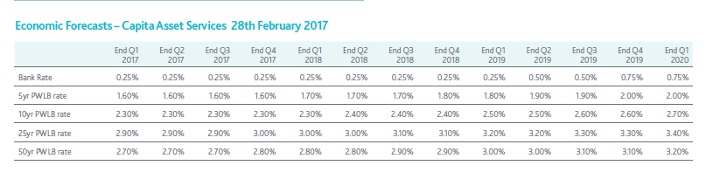

PWLB borrowing rates increased slightly during the autumn/winter as some the concerns over Brexit have decreased but rates are still down to historically low levels. See chart below.

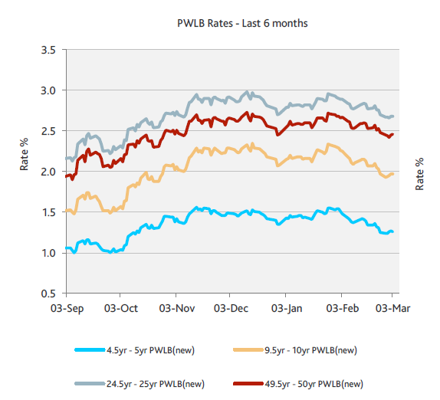

1. **City Council Investments**

As at the 28th February 2017 the Council held £84.7 million of Investments in the following institutions:

|  |  |  |  |  |
| --- | --- | --- | --- | --- |
|  | **Maturity Period** | | | |
|  | **0-3 months** | **3-6 months** | **6-12months** | **>12 months** |
|  | **£millions** | **£millions** | **£millions** | **£millions** |
| Banks | 8.5 | 12.5 | 7.0 |  |
| Building Societies | 13.0 | 5.5 |  |  |
| MMF’s | 17.7 |  |  |  |
| Enhanced Cash Plus |  | 8.0 |  |  |
| Local Authorities |  | 2.5 |  |  |
| Property Funds |  |  |  | 10.0 |
| **Total** | **39.2** | **28.5** | **7.0** | **10.0** |

* Average investment returns in January 2017 was 0.55% for banks and building societies excluding property funds and 0.93% including property funds. This has slipped from August’s report when the equivalent rates were 0.68% and 1.11% respectively. This highlights the difficulty in achieving competitive investment rates at this time. We are currently getting quotes in the range of 0.16% to 0.65%for new 6 months deals as opposed to the 0.62% to 0.80% achieved prior to August.
* Investment duration limits have remained constant at 6 months. As mentioned above banks are not short of cheap available funds and seen as relatively stable institutions.
* Within the medium term financial plan an amount of £746k has been included for investment interest based on an average interest rate of 0.7% excluding property and 1.3% including property funds. With the base rate decrease and the potential for a further decrease it is likely that this financial pressure will increase.

1. **Property Funds**

The Council has invested in three property funds. The primary reason for the Council investing in the CCLA and Lothbury property funds was to achieve a revenue return. Following the Brexit vote, the capital value of these funds fell, as concerns over slower economic growth and in turn demand for commercial/office property grew. As those concerns eased both funds have recovered their value and in the case of Lothbury nearly back to their pre Brexit levels. Both funds are still significantly above their purchase value. Investments in property funds are long term and it is expected that there will be fluctuations of the capital value over the period that the property fund investments are held. More detail on the property funds the Council holds are as follows:

* + **CCLA** – £3 million investment in the Local Authorities Property Fund held in two tranches. The total capital value as at the end of February 2017 was £3,659,851.
  + The Council has enjoyed growth since joining the Fund, however the Brexit result did have a considerable effect on the Fund as shown on the chart below. The fund effectively fell back to July 2015 net asset values. The fund has since recovered some value and the fund managers are confident the Fund will continue to improve via careful asset selection, tenant management and property improvement. The CCLA fund managers took the decision to down value the fund by 3% from £636 million to £617 million as a result of uncertainty in the market due to the Brexit vote. Other property funds in the market have devalued further. As at the 31 December 2016 fund size has grown to £664 million.
  + The Fund managers believe the portfolio of properties remain attractive with strong and robust long-term tenants, low void rates of 4.8%, no gearing and relatively low exposure to City of London and Central London properties.
  + The Fund still allows redemptions.

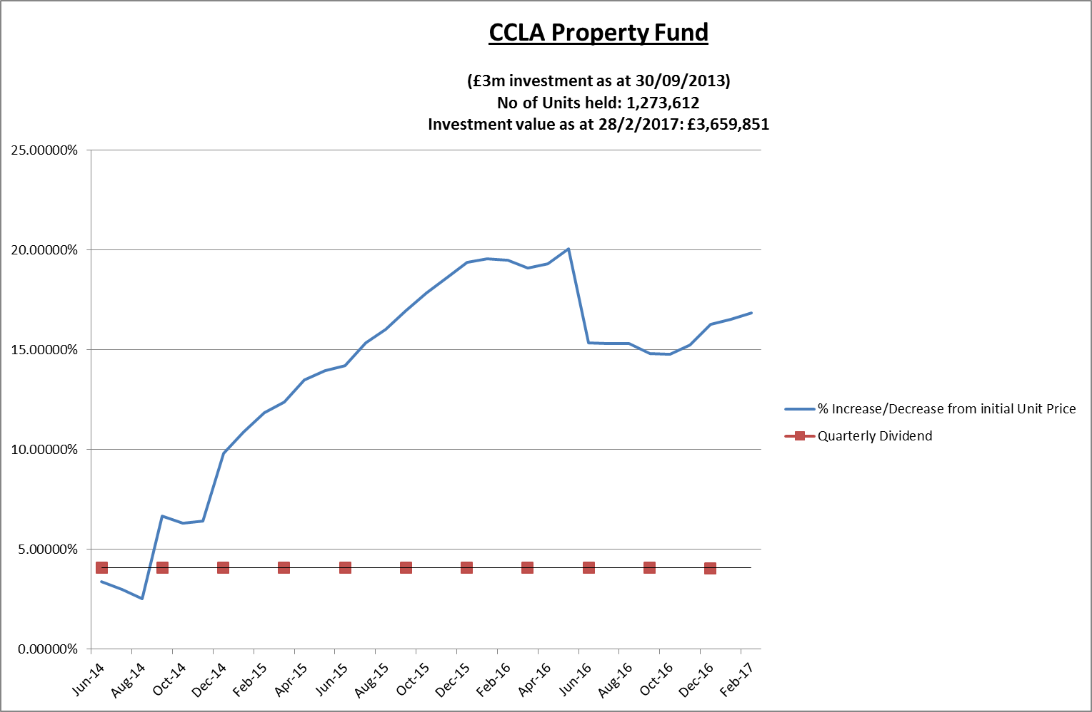

The pie chart below shows the asset allocation by type of the Fund.

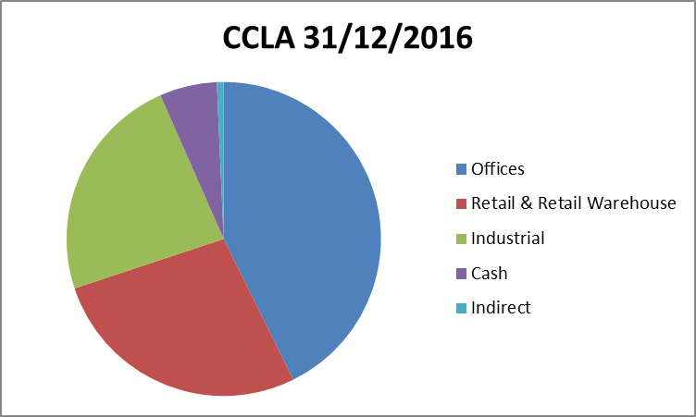

* + **Lothbury** – £7 million is currently invested in the Lothbury Property Fund held in two tranches. The capital value as at the end of February 2017 was £7,814,355.
  + The Council has enjoyed growth since joining the Fund, however the Brexit result did have a considerable effect on the Fund as shown on the chart below. The fund effectively fell back to September 2015 net asset values. However the Fund has recovered strongly and is very close to its pre Brexit levels. The Fund managers believe the Fund comprises investments in prime properties that are high quality, well located and secured with excellent tenants. As at 31 December 2016 fund size was £1.54 billion
  + The Fund still allows redemptions.

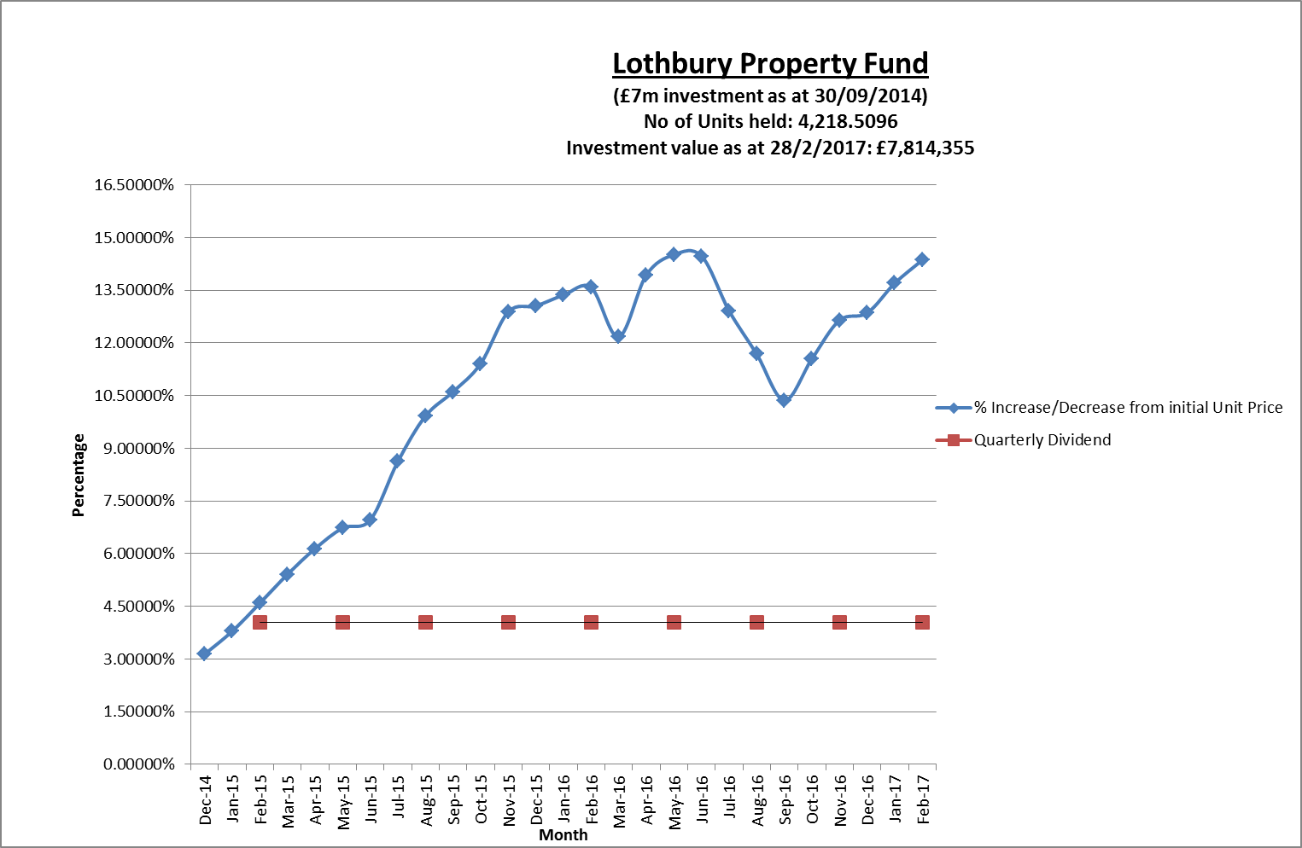

The pie chart below shows the asset allocation by type of the Fund.

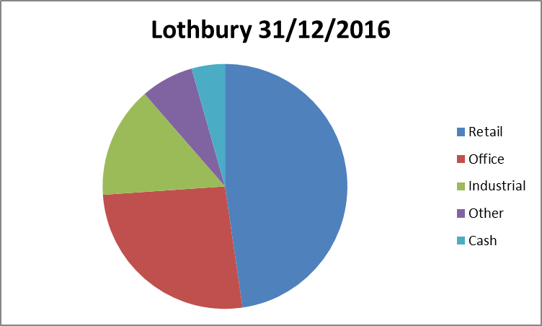

* + **Real Assets Lettings** – The Council has recently invested an amount of £5million with match funding from the Big Society to purchase houses for homeless families. Although essentially this is a service requirement the Council does expect to make around 3% rate of return commencing next financial year plus a share in the uplift in the value of the 50 properties purchased

1. **Borrowing**

Within the Council’s Medium Term Financial Plan provision has been made for the following prudential borrowing:

|  |  |  |  |  |
| --- | --- | --- | --- | --- |
|  | **HRA** | **General Fund** | **Housing Company** | **Total** |
|  | **£000’s** | **£000’s** | **£000’s** | **£000’s** |
| 2017/18 | - | 14,420 | 3,000 | 17,420 |
| 2018/19 | - | 5,039 | 29,000 | 34,039 |
| 2019/20 | - | 708 | 17,000 | 17,708 |
| 2020/21 |  | 705 | 12,000 | 12,705 |
|  |  |  |  |  |
| Total | - | 21,872 | 61,000 | 81,872 |

The Council currently has around £20 million of internal borrowing and reserves and balances of around £60 million which potentially provide additional headroom dependant on the Council’s expenditure profile. However, as highlighted earlier; borrowing rates are at historically low levels so officers are monitoring the situation carefully.

1. **Britain’s Contribution to the EU**

From 2010 to 2015, the UK’s average annual gross contribution to the EU amounted to around £16.8 billion. However the UK also receives a rebate and funding from various EU initiatives. This means that the UK’s average annual net contribution to the EU budget over these same years is estimated to be around £8.8 billion, or around 0.5% of GDP.

Although in the near term budgetary contributions to the EU must still be made, and funding flows into the UK will continue, the longer term position is uncertain and is dependent on the exit negotiations between the UK and the EU. In addition it remains to be seen whether the new UK Government will redirect the money it may save from leaving the EU to similar areas as those benefiting from European funding, including local government. Should savings not materialise, indeed recent reports would seem to indicate a payment to exit the EU, then this could impact on the amount of funding available which no doubt the Government would seek to claw back from local government perhaps by changes to the New Homes Bonus allocations or Business Rates income.

1. **Pound versus Euro**

The pound has fallen consistently against the euro since the Brexit vote to a low of 1.10 euros in October 2016 to 1.15 euros on the 9 March 2017. This compares to a 52 week high of 1.44 euros and a level of 1.3 euros before the Brexit vote. Whilst the fall in the pound has helped exporters it has made foreign holidays more expensive for British tourists.

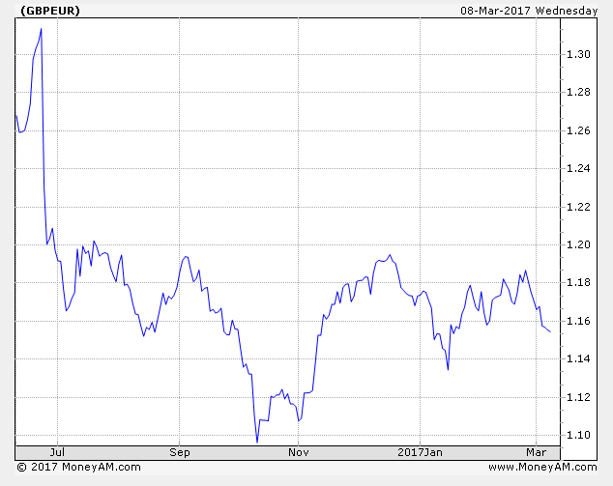

1. **EU Funding**

* The City Council has actively pursued European Funding for relevant projects in recent years. Additionally, the Local Enterprise Partnership (LEP) has secured funding from the European Structural Investment Funds (ESIF) (c£20million). The proposals can be most easily understood as being organised around two headline programmes:

£14.77m (+ match) Business Support Programme

£4.73million Labour Market and Community Development Programme

* In December 2016 the city council were awarded a contract by the Big Lottery Fund to manage a programme of employment support and training for unemployed young people in Oxfordshire. “Unlocking Potential for Oxfordshire” is a new project that will receive up to £734,000 over the next three years as part of the Building Better Opportunities (BBO) programme, jointly funded by the Big Lottery Fund and the European Social Fund (ESF).
* **OxLEP’s Community Grants Programme**

In May 2016, the Council were awarded a contract by the Skills Funding Agency to deliver the Oxfordshire LEP’s Community Grants Programme. The aim of the project is to make small grants to charities and other organisations that help disadvantaged and unemployed people into work or training. The ESF Community Grants programme is running from October 2016 until June 2018.

Individual charities and support organisations can apply for grants of between £5,000 and £50,000 at a time. Grant funding of £390,000 is available over the lifetime of the project, with £37,000 available for the administration of the project.

* **Oxfutures Programme** run by the Low Carbon Hub on behalf of the City Council and County Council - The partnership received £1.2 million of EU grant on the basis that it leveraged 15 times this amount in schemes with local businesses. The target, is 23 million euros or £19.658 million, an increase £1.8 million since the BREXIT decision on 23rd June and the fall in the exchange rate. In the event that the target is not achieved a proportion of grant is repayable to the EU, this may be around £170k in a worst case scenario and a decision from the EU is awaited.

Going forward access to EU funds may not be possible.

1. **EU Obligations**

There are a range of EU obligations affecting local authorities. Procurement, local economic development, waste and employment are all determined by EU regulations. It is probable that some of these regulations will remain enshrined within UK law, others may be repealed or overturned in the fullness of time.

1. **State Aid Rules**

Potentially some EU state aid rules would be relaxed, which could mean it is easier in some circumstances to support companies with public funding when warranted, although we would still have to comply with restrictions that may be imposed as part of a negotiated European Free Trade Agreement. The Council has applied state aid rules in the calculation of interest charged on loans made to the recently established Housing Company and similar calculations will be applied to loans to the Councils Local Authority Trading Company

1. **House Prices**

Many economists believe that house prices could go down because of a potential fall in inward investment. It is fair to say however that even with the recent financial markets fluctuations the average cost of dwellings in Oxford has been upwards.

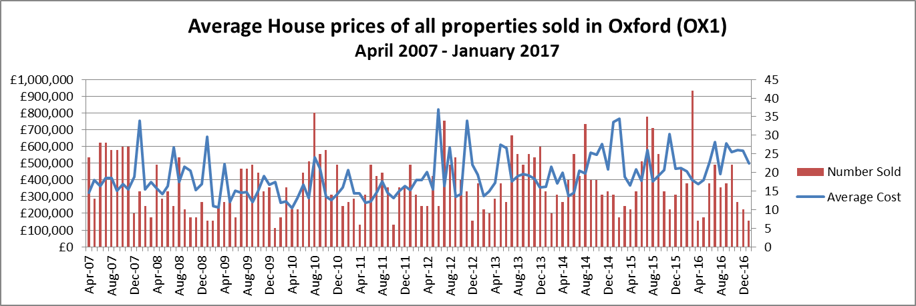

UK house prices accelerated in February 2017 rising by 4.5% in a year according to Nationwide. The outlook for the market however is uncertain with the Nationwide predicting a 2% rise in UK house prices over the course of 2017.

1. **Petrol prices**

Since June 2016 the cost of a litre of diesel has risen 9.4% from 111.8 p to 122.3p The Council uses around £800k of fuel per annum, so this represents a £75k increase.

**13 ) Employment**

The unemployment rate has been falling steadily over the last five years, as the UK recovered from the global financial crisis, which saw up to two million jobs lost, [according to one report](http://www.telegraph.co.uk/finance/jobs/8760594/UK-has-lost-2m-jobs-since-recession.html). Wages have been growing faster than inflation in recent months, [though the gap is narrowing](http://www.bbc.co.uk/news/business-39277539), leading to warnings of squeezed incomes. In the three months to January 2017, regular pay increased by 2.3%, compared with the same period a year earlier. That was sharply lower than the 2.6% seen in the three months to December.

Meanwhile, inflation currently stands at 2.3%, up from 0.5% a month ago.

If the incomes squeeze translates into falling consumer confidence, then the main driver of the better-than-expected economic news since the referendum could turn more negative.

In recent announcements, the TUC advised that nearly 150,000 adult social care and NHS jobs may be at risk if EU workers are no longer to stay in the UK after Brexit. In Oxford City Council we currently have a maximum of 146 employees who may be EU nationals (89 undeclared and 57 specified on ITRENT). The cost of applying for a UK Registration Certificate or Permanent Residence Card is £65 and in order to mitigate additional recruitment costs the Council has agreed to fund this cost at a total potential cost of £9,490.

14) **The Council’s Key Income Streams**

For an indication of what the effect of BREXIT may have on the Councils own income streams it is worth looking at what happened in the last recession and the effect on some of the Council's main income streams, i.e. car parking, planning fees, investment income, commercial property income and Business Rates. It will appreciated that past history may not be reflective of the future.

Following 6 successive quarters of negative growth the UK finally moved out of recession in the final quarter of 2009. The graph below shows the Councils’ main income streams between 2006/07 and 2016/17 which shows the trend before, during and after the recession.

The main observations include:

* The figures for 2016-17 are for 11 months ending 28th February 2017
* Investment income dropped significantly as base rates were cut to 0.5% and will drop further following the cut to 0.25%
* Some dip in car parking income in 2010/11 but equally this could be explained by the transfer of 2 park and ride sites to the County Council. Car parking income in 2016-17 at year end will be in line with 2015-16 levels.
* Planning fees show some plateauing in 2008/2009 but with steady growth thereafter
* Commercial rents have continued to climb over the period, more significantly in 2014/15 which arises due to the switch of car parking income from the Westgate in favour of a fixed rental from the Westgate Development Partnership.

**15) Focus on Investment Property**

The Council has a commercial portfolio that currently is estimated to deliver a rental stream of around £10m in 2016/17.

**Analysis of Commercial Property Rental Income By Type of Holding**



There has been no marked change in income since the Brexit decision.

**16) Business Rates**

The business rates net collectable debit in Oxford City is shown as follows

|  |  |  |  |
| --- | --- | --- | --- |
| **Business Rates Net Collectable Debit** | | | |
|  |  |  | **£000s** |
| 2013/14 |  |  | 85,581 |
| 2014/15 |  |  | 86,669 |
| 2015/16 |  |  | 88,488 |
| 2016/17 |  |  | 89,497 |

The table above shows our Business Rates income has remained resilient despite all the development going on in the City Centre. From October 2017 we can expect to see growth through the new Westgate development. In the latest 2017 draft valuation list (that becomes live on April 1st) we have 22 properties with rateable values of over £1 million totalling £61 million (24% of total rateable value) out of a total of 3,999 properties with a total rateable value of £255 million.

Our second highest assessment is the BMW Motor Vehicle Works in Garsington Road (RV £8.6m). In recent announcements BMW have are said to be looking at plants in Germany as alternatives to Oxford for the production of the new electric Mini amid concerns relating to the possible impact of a hard Brexit. Production of this vehicle is due to commence in 2019 and a decision will be made in the second half of this year. If production is moved away from Oxford the rating assessment could be drastically reduced with the authority dropping to safety net in respect of Business Rates Retention, a loss of around £450k per annum. The knock on effect to the Oxford economy could be significantly worse than this.

|  |  |  |  |
| --- | --- | --- | --- |
|  |  |  |  |